School Of Mechanical & Manufacturing Engineering, NUST

Department of Mechanical Engineering

CS-114 - Fundamental of Programing

**Lab task # 4**

**Course Instructor:** Dr Khwaja Fahad Iqbal

**Lab Instructor:** Muhammad Affan

**Student Name: ZORAIZ ABBAS**

**CMS ID: 454752**

**DATE:**

**19 OCT 2023**

Fundamental of Programing

**Task 1:**

**Answer :**

//program for sum of first ten natural numbers

#include<iostream>

using namespace std;

int main(){

int sum=0,a=0;

for(a=0;a<=10;a++){

cout<<"enter number"<<endl;

cin>>a;

sum=sum+a;

}cout<<"the sum of first ten natural number : "<<sum<<endl;

return 0;

}

**Result:**

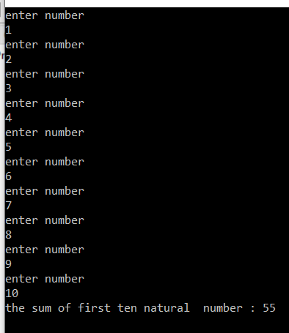

**Task 2:**

**Answer :**

//program for table

#include<iostream>

using namespace std;

int main(){

int a=1,table;

cout<<"enter number"<<endl;

cin>>table;

while(a<=10){

cout<<table <<" x "<< a << " = "<< table*a<<endl;

a++;}

return 0;

}

**Result**:

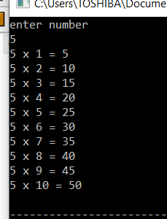

**Task 3:**

**Answer :**

// program for factorial

#include<iostream>

using namespace std;

int main(){

int num=0,factorial=1;

cout<<"enter the number"<<endl;

cin>>num;

while(num>0){

factorial=factorial*num;

num-=1;

}

cout<<"the factorial is :"<<factorial<<endl;

return 0;

**}**

**Result:**

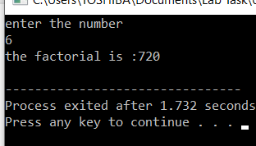

**Task 4:**

**Answer:**

//progarm for fibonacci sequence

#include<iostream>

using namespace std;

int main(){

int x=0,y=1,end,a,newterm;

cout<<"The Number of terms in Fibonacci Sequence: ";

cin>>end;

cout<<x<<endl;

cout<<y<<endl;

while(a<end-1){

newterm = x+y;

cout<<newterm<<endl;

x=y;

y=newterm;

a++;

}

return 0;}

**Result**:

